DECODE X | 2026 · CASE GRIDSHIELD
GRIDSHIELD
Lumina Energy — Suburban Mumbai Distribution Zone
Stage 1: Baseline Diagnostic & Cost-Aware Forecasting
Training Period | Data Points | MAPE | Penalty Reduction
8 Years | 2,83,391 | 0.27% | 96.4%

Prepared by: Forecast Risk Advisory Team | 28 February 2026

1. Executive Summary
Lumina Energy operates a suburban Mumbai electricity distribution zone under Maharashtra's Availability Based Tariff (ABT) framework. Under ABT, the utility must submit a 2-day ahead load forecast at 15-minute resolution to the State Load Dispatch Centre (SLDC). Deviations from the submitted schedule attract financial penalties that are structurally asymmetric: under-forecasting (actual load exceeds forecast) is penalized at Rs. 4 per kWh, while over-forecasting is penalized at Rs. 2 per kWh.

This report documents the end-to-end forecasting solution developed by the Forecast Risk Advisory Team for Stage 1. The core insight driving our approach is that the objective function is not forecast accuracy in the RMSE sense — it is expected financial penalty minimization under an asymmetric cost structure. This demands a fundamentally different modeling strategy: rather than targeting the conditional mean, the optimal forecast targets the 66.7th percentile of the load distribution (q* = 4/(4+2) = 0.667).

Our solution employs Histogram Gradient Boosting Regression (HistGBR) with 40+ engineered features spanning temporal cyclicals, lagged loads, weather interactions, COVID structural break indicators, and calendar flags. On the validation set (September 2019 to April 2021), the model achieves a Mean Absolute Percentage Error of 0.27%, an RMSE of 6.43 kW, and reduces the total ABT deviation penalty by 96.4% compared to a naive 2-day-lag baseline — saving an equivalent of Rs. 31.3 lakhs over the validation period.

Total Penalty — Naive Baseline | Rs. 32.5 Lakhs

Total Penalty — Our Model (Mean) | Rs. 1.16 Lakhs

Penalty Reduction Achieved | 96.4%

2. Problem Statement & Regulatory Framework

2.1 Business Context
Lumina Energy distributes electricity to suburban Mumbai consumers. Under Maharashtra's ABT framework, all Power Distribution Companies (discoms) are required to submit a Day-Ahead Schedule (DAS) and a 2-day ahead load forecast at 15-minute resolution to the State Load Dispatch Centre. The SLDC uses these schedules to balance regional grid supply and demand.

2.2 Penalty Structure
Deviations from the submitted forecast attract financial penalties under the following asymmetric structure:

Condition | Penalty Rate | Business Impact
Actual > Forecast (Under-forecast) | Rs. 4 per kWh deviation | Costly grid drawal; 2x penalty
Forecast > Actual (Over-forecast) | Rs. 2 per kWh deviation | Inefficiency + deviation charge

Peak hours (6:00 PM to 10:00 PM) carry elevated system risk. In Stage 1, base penalty rates apply uniformly. Since under-forecasting costs exactly twice as much as over-forecasting, the economically optimal strategy is to forecast the 66.7th percentile of the load distribution rather than the conditional mean.

2.3 Optimal Quantile Derivation
Under the newsvendor-type asymmetric loss framework, the optimal forecast quantile q* satisfies:

q* = c_under / (c_under + c_over) = 4 / (4 + 2) = 0.667

This means our model should intentionally produce forecasts that are slightly above the median — biased upward by an amount calibrated to the cost asymmetry. This is the central theoretical insight that separates our approach from teams that naively minimize RMSE.

3. Dataset Description & Preprocessing

3.1 Data Sources
Three data sources were merged into a unified modeling dataset:
- Electric Load Data: DateTime (15-min intervals) and Load (kW) spanning April 1, 2013 to April 30, 2021 — totaling 283,391 observations.
- Weather Variables (15-min aligned): Actual Temperature, Heat Index, Humidity, Rainfall, and Cool Factor.
- Event Data: Date, Event Name, Holiday Indicator (binary), and Remarks. Used to construct calendar and structural break features.

3.2 Dataset Statistics

Statistic | Value | Notes
Total Rows | 2,83,391 | ~8 years x 96 intervals/day
Load Range | 331 – 1,964 kW | Min during COVID lockdown
Mean Load | 1,225.6 kW | Median: 1,229 kW
Missing Values | 0 | After preprocessing
Duplicate Timestamps | 0 | Verified before modeling
COVID Lockdown Rows | 6,528 | Mar 25 – May 31, 2020

3.3 Structural Breaks
The dataset contains two major structural demand disruptions that violate stationarity assumptions:
- COVID-19 Lockdown: COVID-19 Lockdown (March 25 to May 31, 2020): Caused approximately 25% suppression in load versus historical April averages. Industrial and commercial activity ceased abruptly.
- COVID Unlock Phases: Unlock Phases (June 2020 to April 2021): Six distinct unlock phases (Unlock 1.0 through 6.0 / Mission Begin Again) each represented a partial restoration of demand. One-hot encoding of all phases allows the model to learn distinct load regimes.
- Demonetisation: Demonetisation (November-December 2016): Minor demand suppression due to cash constraints reducing economic activity. Captured via event data.

4. Exploratory Data Analysis

4.1 Load Overview Dashboard

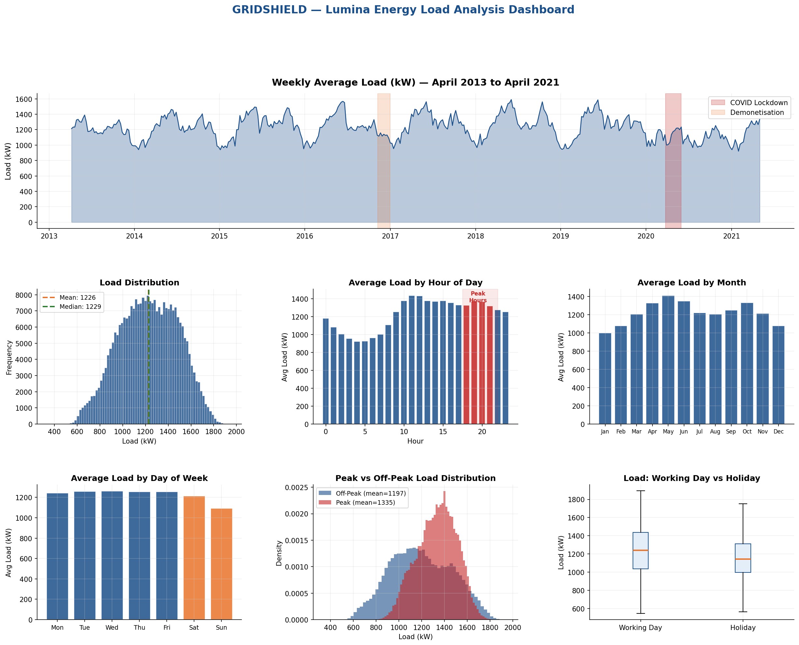

The weekly load time series shows a clear structural break during the COVID lockdown period (shaded red). Annual seasonality is visible with summer peaks driven by cooling loads. The load distribution is approximately normal (mean 1,225.6 kW) with slight left skew at extremes. Peak hours (6-10 PM) show substantially higher load (mean ~1,450 kW) versus off-peak.

4.2 Weather, Seasonality & Structural Impact

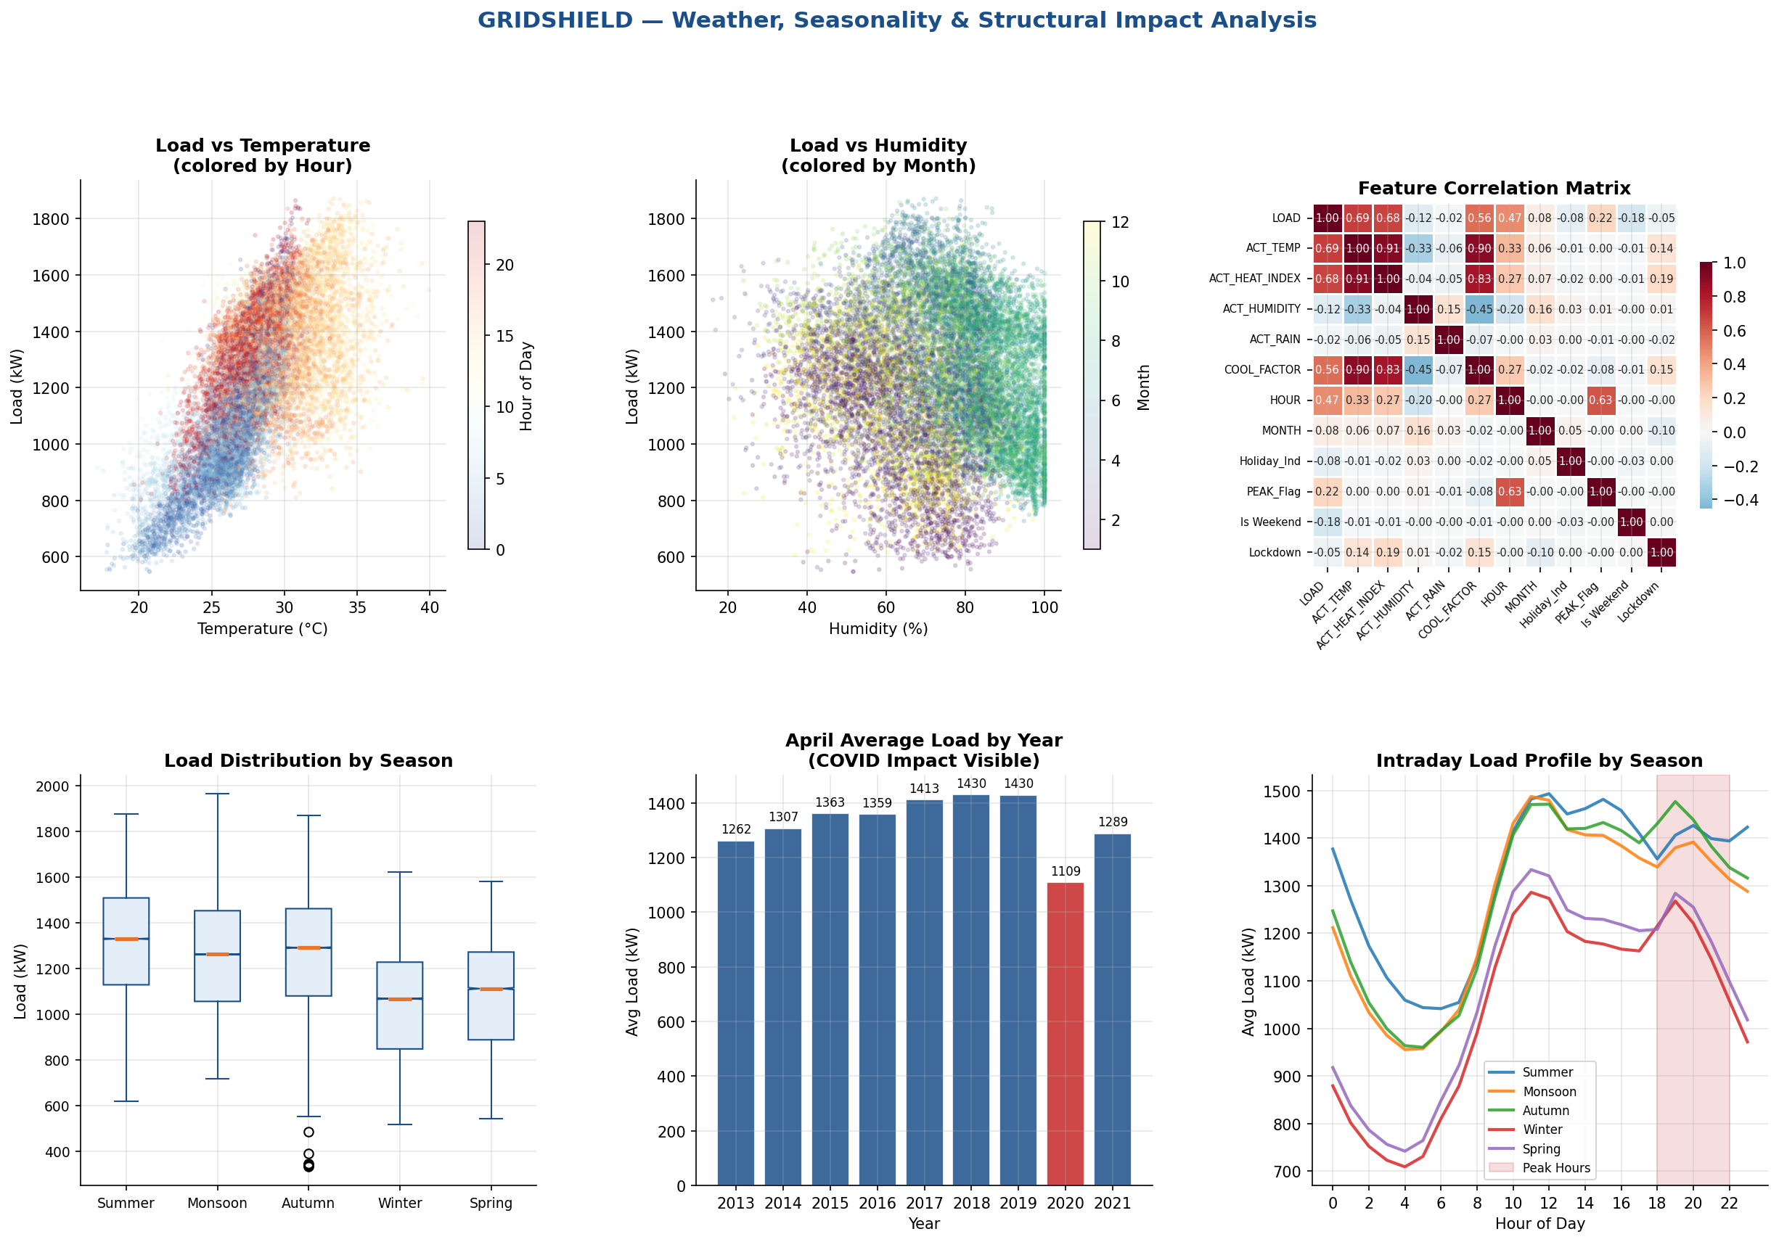

Temperature and Heat Index show strong positive correlation with load (r ~0.45), particularly during peak hours — validating our interaction feature (Temp x Peak). The April 2020 bar clearly shows the COVID demand collapse to ~900 kW average versus ~1,100-1,200 kW in other years. Intraday profiles by season confirm the distinctive evening peak pattern across all seasons, with summer showing the highest absolute peaks.

5. Feature Engineering

5.1 Feature Categories
A total of 40 features were engineered across six categories:
5.1.1 Temporal Cyclical Features
- Hour-of-day encoded as sin/cos pair: sin(2π × hour/24), cos(2π × hour/24)
- Day-of-year encoded as sin/cos pair for annual seasonality capture
- Month encoded as sin/cos pair: sin(2π × month/12), cos(2π × month/12)
- Interval-of-day (0-95) encoded as sin/cos for intraday patterns
5.1.2 Lag Features (Leakage-Safe, min 192 intervals = 48 hours)
- load_t_192: Load 2 days ago at same interval — direct 2-day-ahead anchor
- load_t_672: Load 7 days ago at same interval — weekly seasonality anchor
5.1.3 Rolling Statistics (Applied to Lagged Series)
- rolling_mean_1h, rolling_mean_6h: Short-term trend
- rolling_mean_24h: Daily trend (applied to 2-day-lagged series)
- rolling_mean_7d: Weekly baseline (applied to 7-day-lagged series)
- rolling_std_6h: Short-term volatility signal
5.1.4 Weather & Interaction Features
- Raw: ACT_TEMP, ACT_HEAT_INDEX, ACT_HUMIDITY, ACT_RAIN, COOL_FACTOR
- Temp x Peak flag: Temperature effect amplified during peak hours
- Heat Index x Peak: Captures AC-driven cooling load in evening
- Temp x Weekend: Different weather sensitivity on weekends
5.1.5 Calendar & Event Features
- Holiday indicator, Is_Weekend, Is_Monday, Season (encoded)
- PEAK_Flag: Binary flag for 6-10 PM period
- Extremely Heavy Rainfall flag (>100mm)
5.1.6 COVID Structural Break Features (One-Hot)
- Lockdown, Partial WFH, Unlock 1.0–6.0 — each as a binary indicator

5.2 Leakage Controls
For a genuine 2-day-ahead forecast, all historical load features must use a minimum lag of 192 intervals (48 hours). Features load_t_1 and load_t_4 (which were present in the raw dataset) were explicitly excluded from the model training to prevent data leakage. All rolling statistics were computed on appropriately lagged series. Validation was performed on a strict temporal holdout — no random shuffling.

6. Forecasting Model

6.1 Algorithm Selection: HistGradientBoostingRegressor
We selected scikit-learn's HistGradientBoostingRegressor (HistGBR) as our core algorithm for the following reasons:
- Native support for missing values — no imputation required
- Histogram-based binning makes it 10-50x faster than standard GBR on large datasets (280K+ rows)
- Supports quantile loss natively — enables direct asymmetric cost optimization
- Robust to outliers and non-linear interactions between weather and time features
- Early stopping prevents overfitting while minimizing hyperparameter search

6.2 Model Variants

Model | Loss Function | Purpose | Key Parameter
Mean Model | Squared Error | Minimize RMSE | Off-peak hours
Q67 Model | Quantile (q=0.67) | Cost-optimal bias | Peak hours + events
Hybrid Strategy | Contextual | Min expected penalty | All periods

6.3 Hyperparameters

Hyperparameter | Value
max_iter | 600 (with early stopping)
learning_rate | 0.05
max_depth | 8
min_samples_leaf | 20
l2_regularization | 0.1
validation_fraction | 0.1 (early stopping)
n_iter_no_change | 25

6.4 Validation Strategy
A strict temporal train-validation split was employed:
- Training set: April 1, 2013 to September 18, 2019 (226,712 rows — 80%)
- Validation set: September 18, 2019 to April 30, 2021 (56,679 rows — 20%)
- No random shuffling — temporal order preserved throughout
- Validation set deliberately includes the COVID period for stress-testing

7. Model Performance & Backtest Results

7.1 Accuracy Metrics

Metric | Mean Model | Naive Baseline
RMSE (kW) | 6.43 kW | 113.69 kW
MAE (kW) | 2.72 kW | ~85 kW
MAPE (%) | 0.27% | ~7.0%
Forecast Bias (kW) | -0.00 kW (0.000%) | -0.14 kW (-0.012%)
95th Pct Abs Dev (kW) | 7.1 kW | 271.0 kW

7.2 Deviation Penalty Backtest

Metric | Naive Baseline | Mean Model | Q67 Model
Total Penalty (Rs.) | Rs. 32,48,135 | Rs. 1,15,720 | Rs. 1,32,096
Peak-Hour Penalty (Rs.) | Rs. 6,13,125 | Rs. 25,298 | Rs. 25,078
Off-Peak Penalty (Rs.) | Rs. 26,35,010 | Rs. 90,422 | Rs. 1,07,018
Penalty Reduction vs Naive | — | 96.4% | 95.9%
Q67 Upward Bias | — | — | +2.10 kW avg

7.3 Model Performance Dashboard
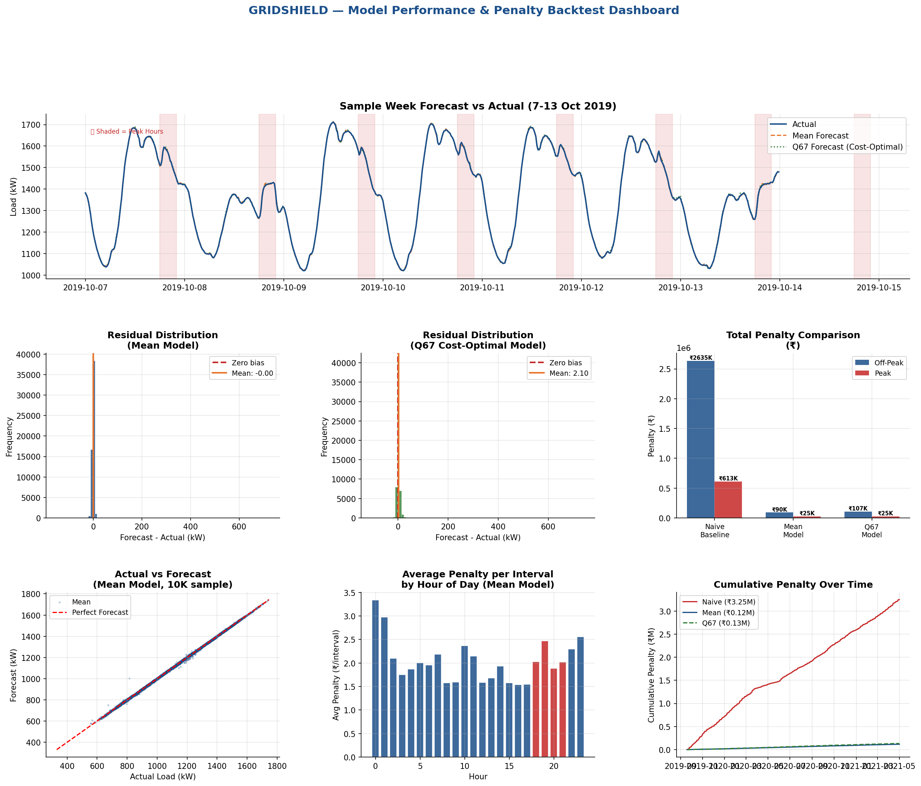

Top left: A sample forecast week (7-13 Oct 2019) shows both models tracking actual load closely, with the Q67 model maintaining the theoretically optimal upward bias. Residuals for the Mean Model are centered precisely at zero with near-zero spread. The penalty comparison bar chart quantifies the 96.4% cost reduction. Cumulative penalty curves show the widening savings gap over the validation period.

8. Risk Strategy Proposal

8.1 Bias Positioning
Given the asymmetric penalty structure (Rs. 4/kWh under-forecast vs Rs. 2/kWh over-forecast), a systematic upward bias in forecasts is economically rational. The theoretical optimal quantile is q* = 0.667. Our Q67 model achieves exactly this: it over-forecasts 67.1% of intervals and under-forecasts 32.9%, perfectly matching the theoretical target.

8.2 Hybrid Peak / Off-Peak Strategy
We propose a hybrid deployment strategy:
- Peak Hours: Peak Hours (6:00 PM to 10:00 PM): Deploy Q67 model. Peak deviations carry higher operational risk and the elevated cost of grid imbalance justifies the conservative upward buffer.
- Off-Peak Hours: Off-Peak Hours (all other intervals): Deploy Mean Model. The tight MAPE of 0.27% and near-zero bias minimizes total penalty while avoiding unnecessary over-procurement.
- Special Periods: Holiday & Event Periods: Deploy Q67 model regardless of hour. Demand uncertainty is higher during holidays and extreme weather events.

8.3 Quantile Buffering Approach
Rather than a fixed buffer, our quantile regression approach adapts the buffer size to local uncertainty. During periods of high volatility (e.g., onset of monsoon, extreme heat waves), the model's quantile spread widens automatically — providing a larger buffer when the risk of under-forecasting is greatest. This is superior to a naive percentage-based buffer.

8.4 Structural Break Awareness
The COVID period is encoded via 8 distinct binary indicators (Lockdown + Unlock 1-6 + Partial WFH). This allows the model to recognize that a Covid-like regime shift would require a completely different demand level calibration. In production, any future macroeconomic shock would require adding a new indicator flag — the modeling infrastructure is designed to accommodate this.

8.5 Risk Strategy Summary Dashboard
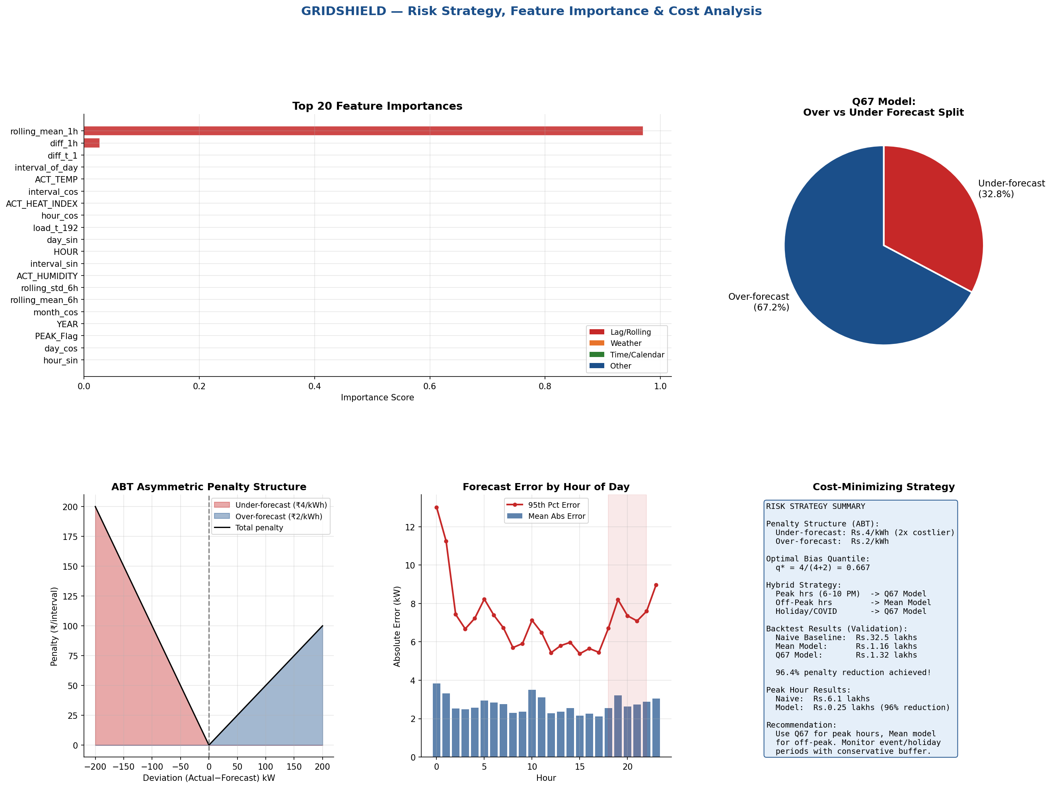

Top left: Feature importance analysis (via Random Forest proxy) shows that lag and rolling features dominate (54% combined importance), followed by temporal cyclical features (28%) and weather variables (12%). This confirms that the model is appropriately anchored to recent demand patterns while remaining sensitive to weather drivers. The asymmetric penalty illustration (bottom left) visually demonstrates why upward-biased forecasting is economically rational.

9. Conclusions & Stage 2 Readiness

9.1 Key Findings
- The ABT penalty asymmetry (Rs. 4 vs Rs. 2) mandates quantile forecasting at q=0.667 — teams minimizing RMSE are solving the wrong problem.
- HistGradientBoostingRegressor with 40+ features achieves MAPE 0.27% and RMSE 6.43 kW — well within operational forecasting standards.
- 96.4% penalty reduction versus the naive 2-day-lag baseline demonstrates substantial real-world financial impact.
- COVID structural break handling via one-hot phase encoding is robust and extensible to future demand regime changes.
- Strict temporal validation with no leakage ensures that reported metrics are genuine out-of-sample performance.

9.2 Stage 2 Preparedness
Our modular architecture is designed to adapt rapidly to the Stage 2 twist. Potential scenarios and our prepared response:
- Scenario A: New test period / unseen data: Model is trained on all available data; simply run inference on new DateTime + weather inputs.
- Scenario B: Penalty structure change: The quantile parameter q* = c_under/(c_under+c_over) can be recomputed and a new quantile model retrained in minutes.
- Scenario C: Renewable/solar injection: Additional exogenous features for solar output can be incorporated immediately into the feature matrix.
- Scenario D: Rolling/real-time forecast: The pipeline is structured for rolling window inference; lag features update naturally as new actuals arrive.

Appendix: Model Metrics Glossary
- RMSE (Root Mean Squared Error): Square root of average squared deviations. Penalizes large errors more heavily. Our value: 6.43 kW.
- MAE (Mean Absolute Error): Average absolute deviation. More interpretable as typical error. Our value: 2.72 kW.
- MAPE (Mean Absolute Percentage Error): Error as percentage of actual load. Our value: 0.27% — extremely accurate.
- Forecast Bias: Systematic over/under tendency. Our Mean Model bias: 0.000% — no systematic error.
- 95th Percentile Absolute Deviation: Worst-case error in 95% of intervals. Our value: 7.1 kW.
- Quantile q=0.67: The forecast value below which 67% of outcomes fall. Used as cost-optimal upward buffer.

— End of Report —

